What should be installed on server to let it works (my installed history)

THis will be useful when my Windows will have the next BlueScreen and reinstall

1. Install PyCharm

2. in Python (by pip) install Flask, Flask-Redis-Helper, redis as in the screen below

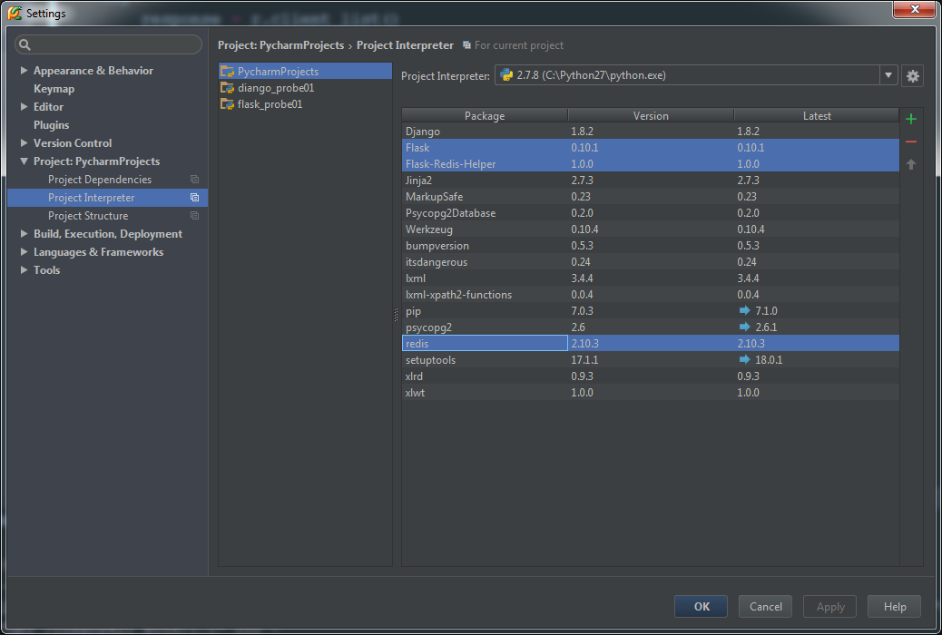

3. to start Windows Service named Redis, see instruction below ([scource](http://stackoverflow.com/questions/6476945/how-do-i-run-redis-on-windows))

1. Download and extract the [RedisWatcher binaries from the 2.4 branch](https://github.com/MSOpenTech/redis/raw/2.4/msvs/bin/release/rediswatcherbin.zip)
2. Run InstallWatcher.msi. This should create a Windows service called Redis watcher.
3. Open up the Windows Services console and start the Redis watcher service.
4. (optional) RedisWatcher should have installed to C:\Program Files (x86)\RedisWatcher. There you'll find a config file called watcher.conf, which you can edit to set up additional instances, use different paths than I specified in steps 2 & 3, etc. You will not need to restart the service for changes to take effect.

4.(optionally) install Redis client from <http://ruilopes.com/redis-setup/>